Team 2:
DataCom: OSPF, EIGRP and GRE Tunnels
NMS: NMP-based Network Management System using OpenNMS, RESTCONF, NETCONF

TEAM 2 PROJECT
This project demonstrates the implementation of enterprise routing protocols and secure tunneling in a simulated network environment, along with NETCONF-based automation.
Key Technologies Implemented:
- Multi-Area OSPFv2 (IPv4)
Link-state routing with backbone and non-backbone areas
- OSPFv3 (IPv6)
IPv6 routing and neighbor establishment
- EIGRP AS 100 Configuration
Hybrid routing protocol with fast convergence
- GRE Tunnel over OSPF
Virtual point-to-point tunnel for secure reachability
- NETCONF Automation using Python
Automated OSPFv2 configuration push using ncclient
Simulation Tool
- GNS3 for network design, configuration, and testing

TOPOLOGY :
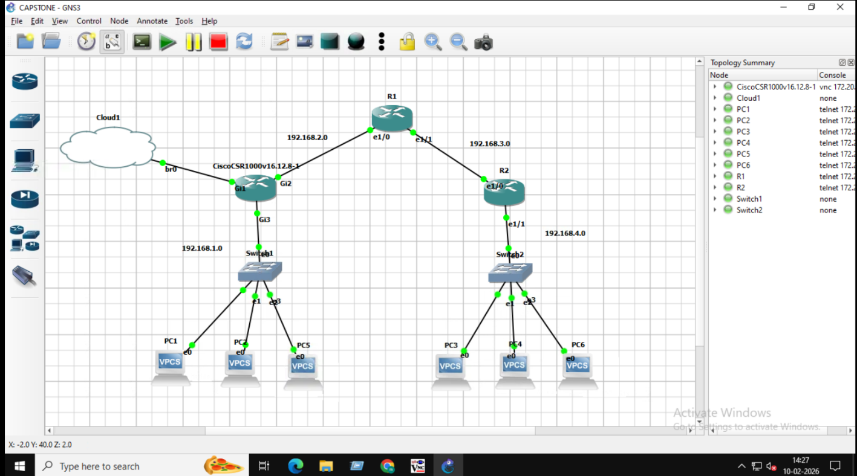

Network Addressing Plan and Interface Allocation
Device | Interface | IP Address | Subnet Mask
R3 | Gi3 (LAN) | 192.168.1.1 | 255.255.255.0
R3 | Gi2 (to R1) | 192.168.2.1 | 255.255.255.252
R1 | e1/0 (to R3) | 192.168.2.2 | 255.255.255.252
R1 | e1/1 (to R2) | 192.168.3.1 | 255.255.255.252
R2 | e1/0 (to R1) | 192.168.3.2 | 255.255.255.252
R2 | e1/1 (LAN) | 192.168.4.1 | 255.255.255.0

IPv4 Addressing Plan for PCs:
- Left LAN (PC1–PC2–PC5 Network): 192.168.1.0/24
- Right LAN (PC3–PC4–PC6 Network): 192.168.4.0/24
Router Interface IP Configuration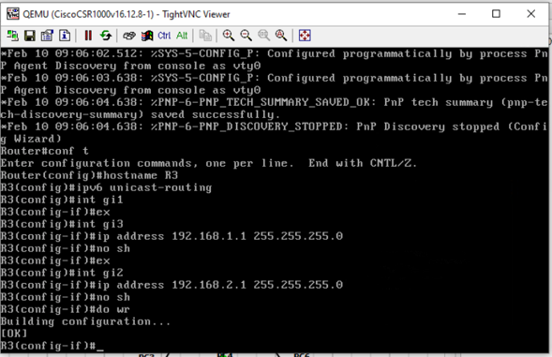
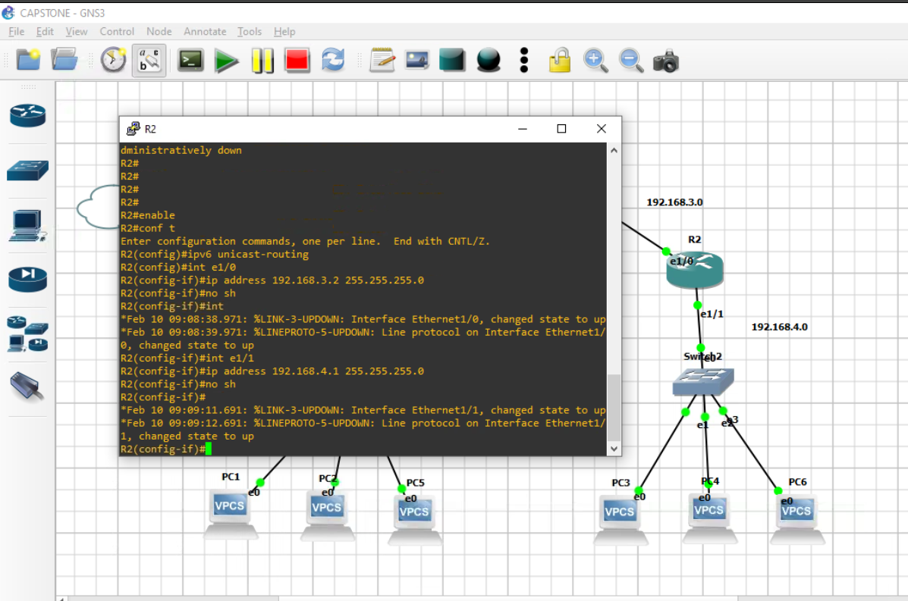

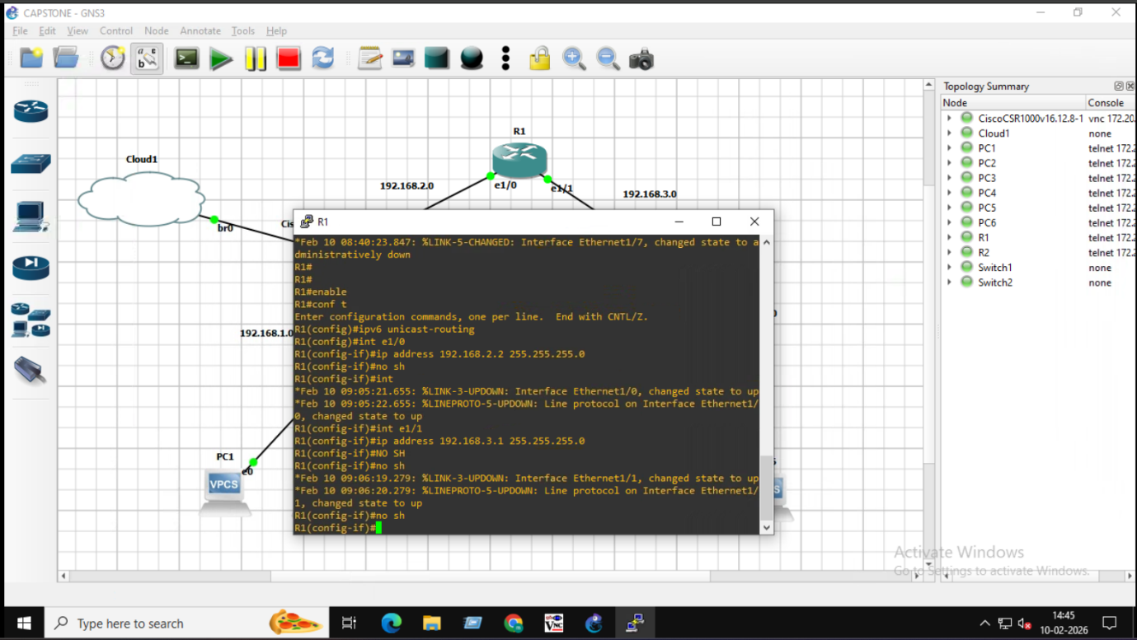

MULTI-AREA OSPFv2 (IPv4)

Multi-Area OSPF is an OSPF design where the network is divided into multiple smaller areas instead of using a single large area.
It improves scalability and performance by reducing routing overhead

Key Points
- Area 0 is the Backbone Area
- Other areas (Area 1, Area 2, etc.) connect to Area 0 through ABRs (Area Border Routers)
- LSAs are limited within an area, reducing LSDB size
- Faster convergence and efficient routing in large enterprise networks
Area Assignment
- Left LAN → Area 1
- Backbone → Area 0
- Right LAN → Area 2
R3 (Area 1)
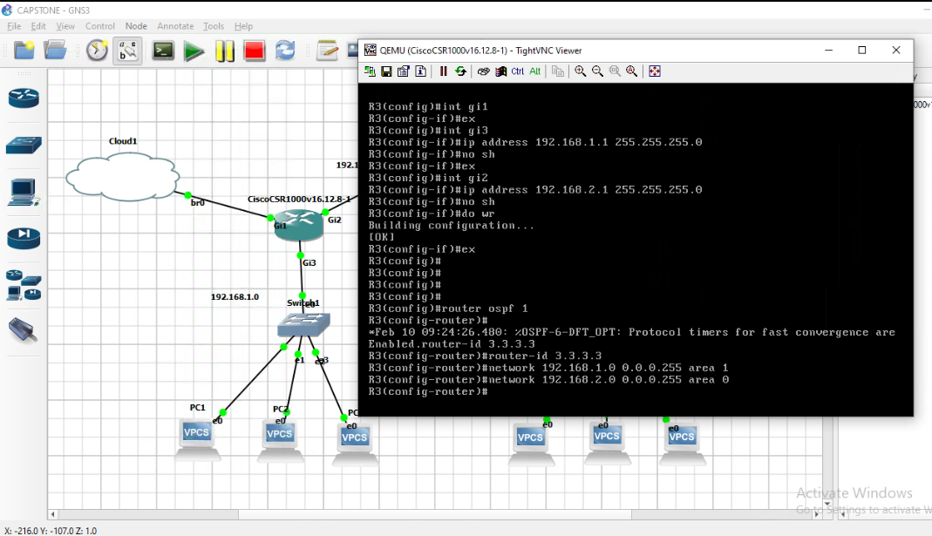

R1 (Area 0)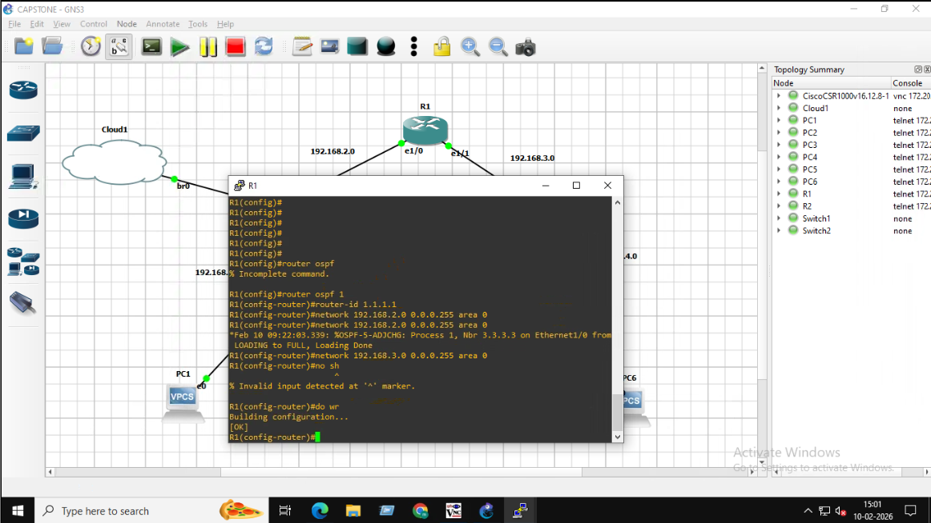

R2 (Area 2)
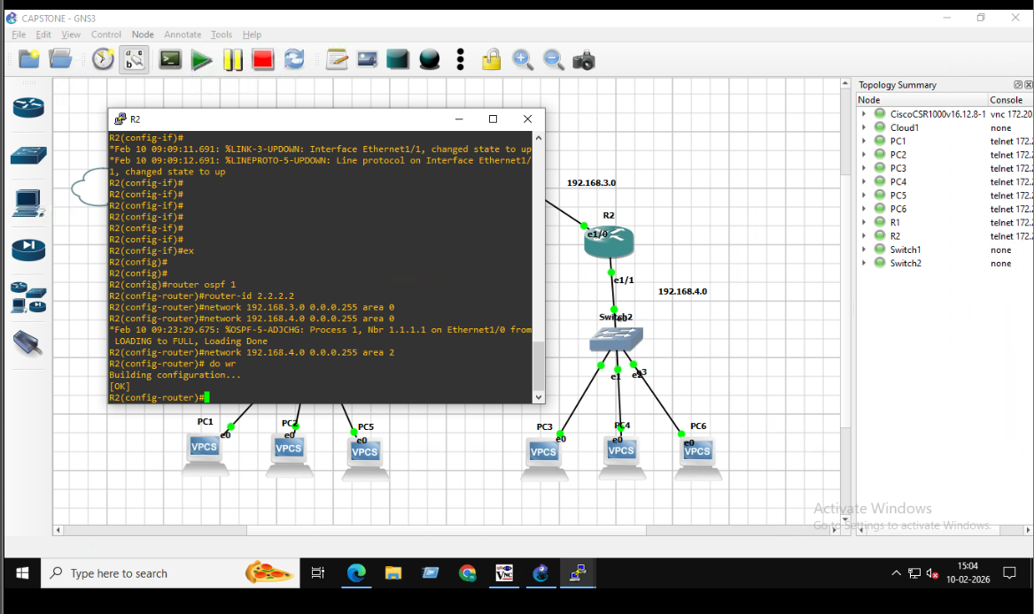

Verify OSPF
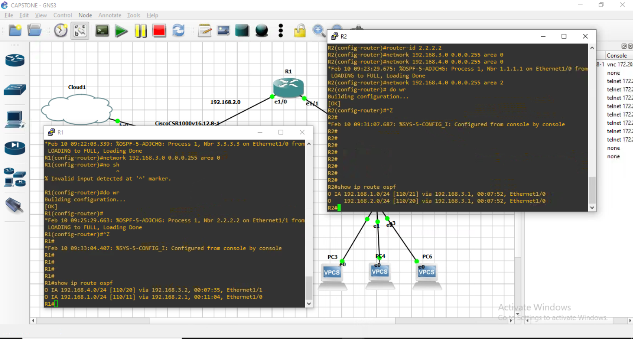
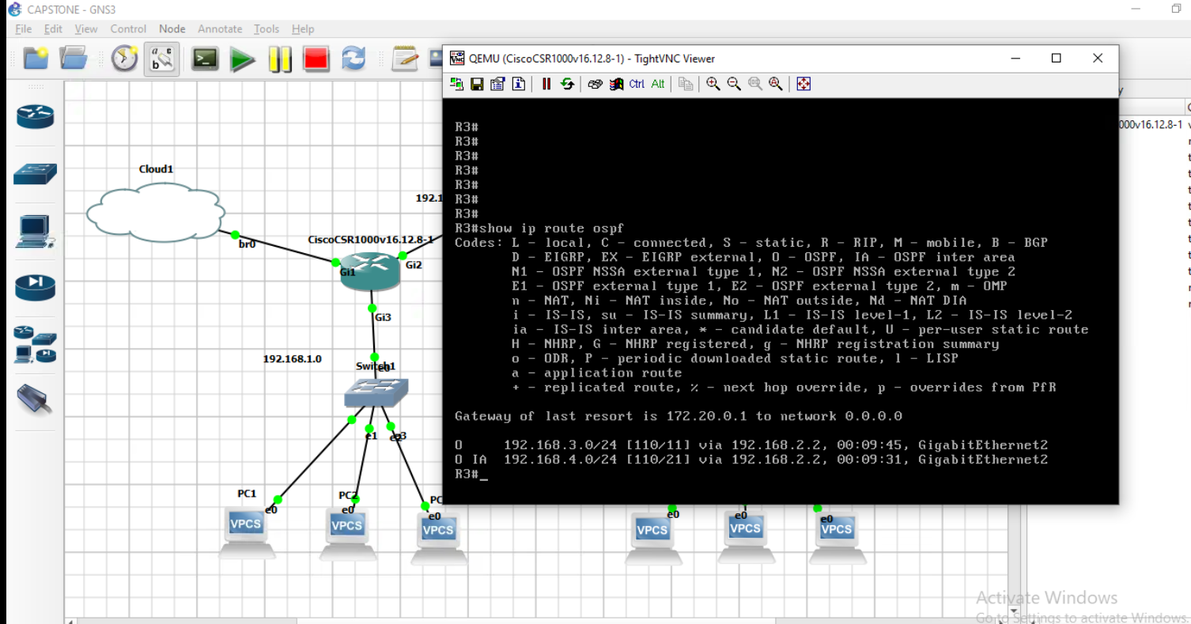

FULL OSPFv3 (IPv6)
Link | IPv6 Network
Left LAN | 2001:DB8:1::/64
R3 ↔ R1 | 2001:DB8:12::/64
R1 ↔ R2 | 2001:DB8:23::/64
Right LAN | 2001:DB8:4::/64
Configure OSPFv3 between the 3 routers

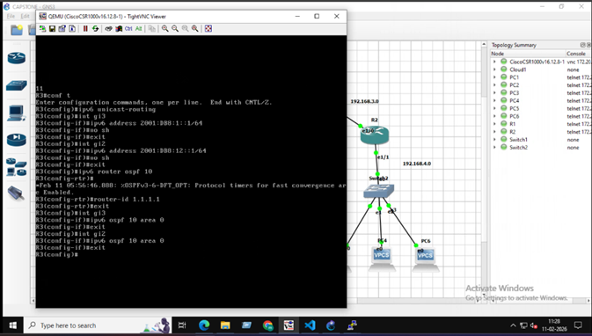
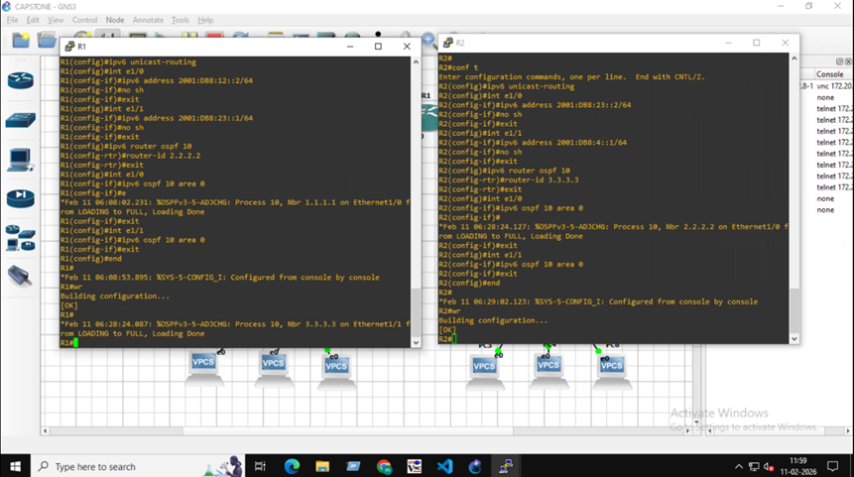
Verification
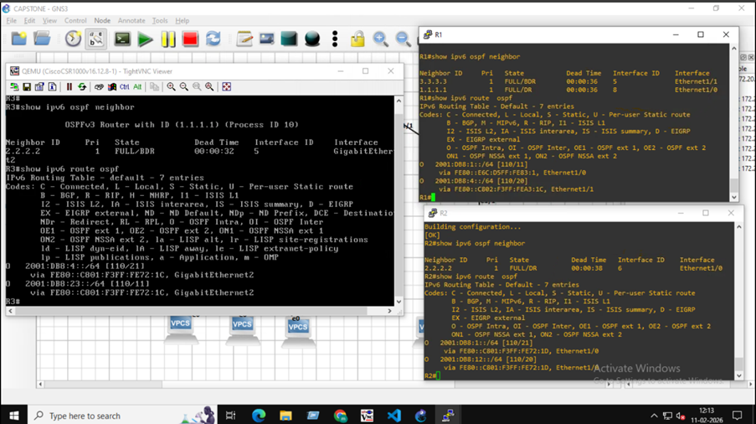

EIGRP AS 100 (3 Routers + PCs)
EIGRP (Enhanced Interior Gateway Routing Protocol) is a Cisco-developed dynamic routing protocol used to share routing information between routers within the same autonomous system (AS).
Key Characteristics
§Uses DUAL (Diffusing Update Algorithm)
finds best path
find backup path
prevent routing loops
§Provides fast convergence
§Uses Bandwidth and Delay to calculate best path
§Maintains Neighbor Table, Topology Table, and Routing Table

Enable EIGRP AS 100 on Routers
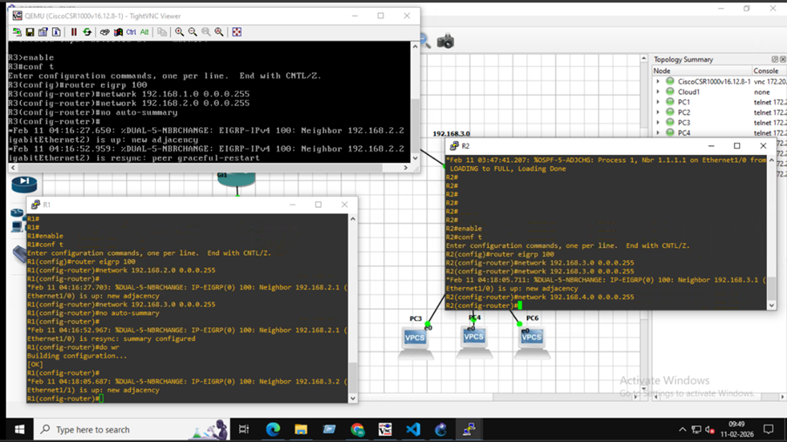
Verify EIGRP
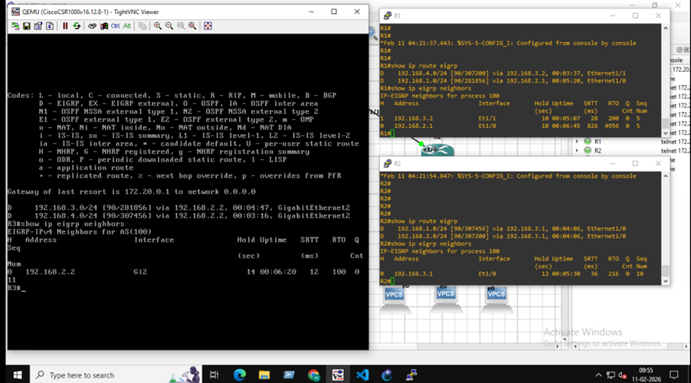

Test Connectivity
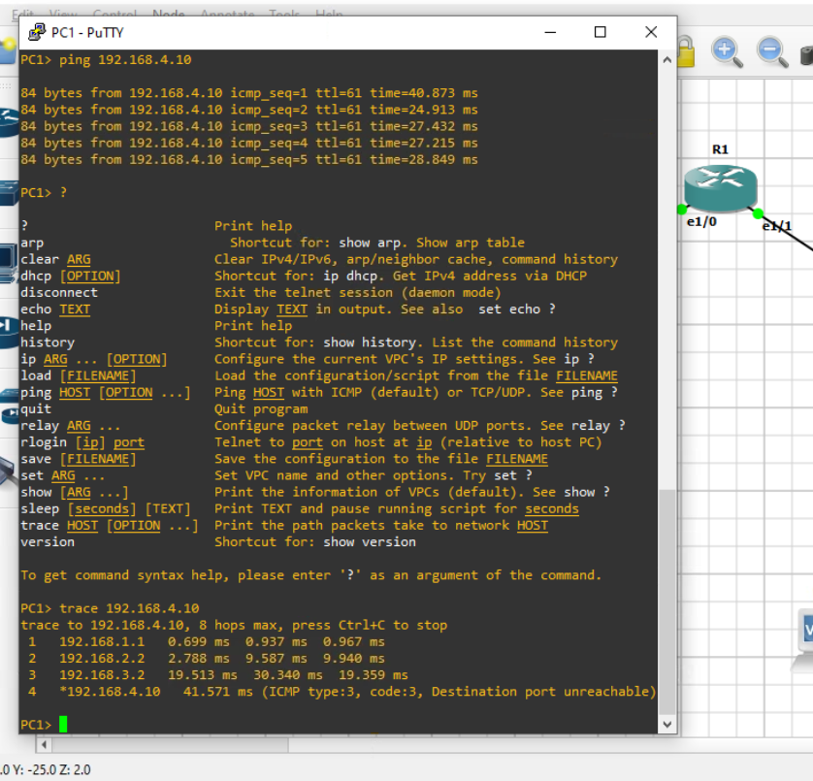

Task #2: GRE Tunnel Over OSPF (R2 ↔ R3)
Tunnel Network: 10.10.10.0/30
§GRE (Generic Routing Encapsulation) creates a virtual tunnel between R2 and R3
§Runs over the existing OSPF
§networkEncapsulates packets to allow communication between remote networks

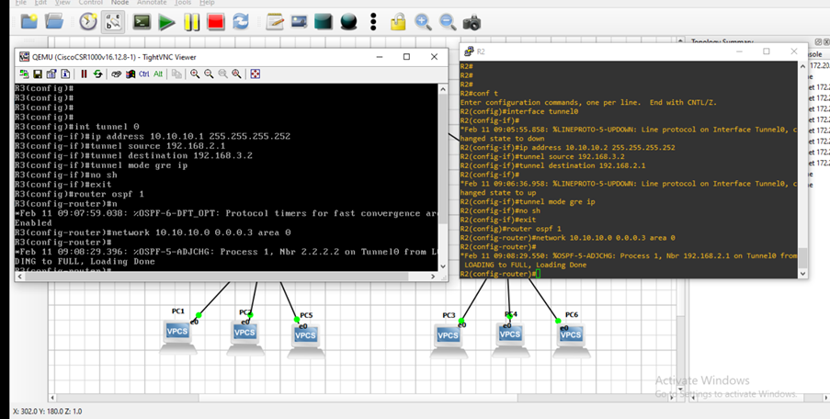
Verification
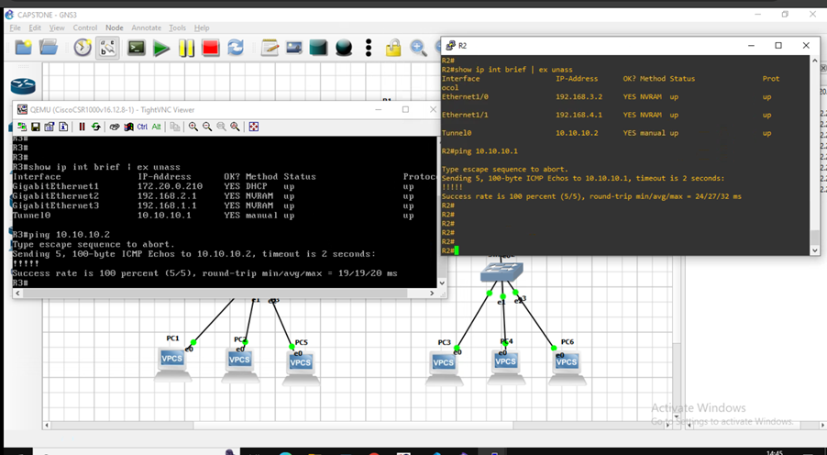

Enable NETCONF on Routers
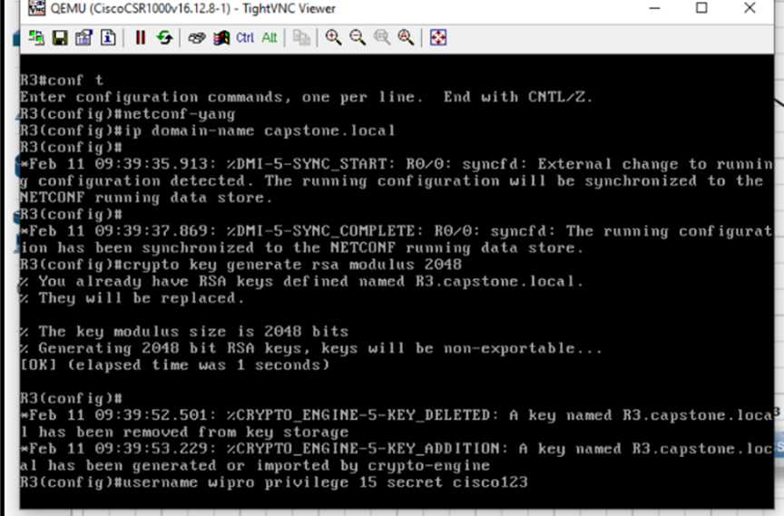
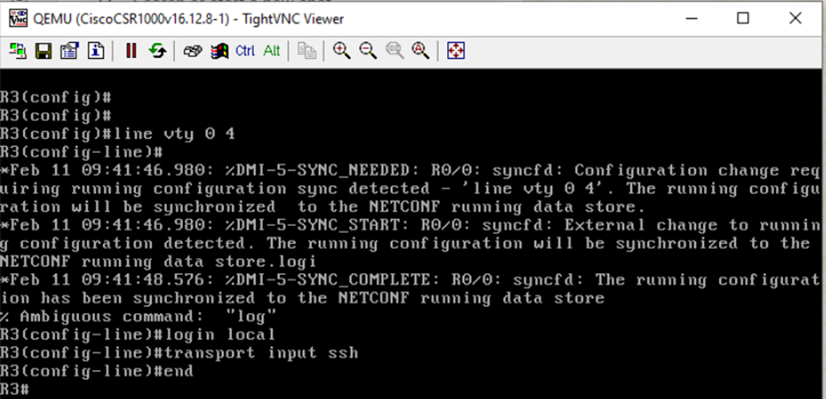
PYTHON Library used : ncclient
NETCONF Connection Script:
- Connect to router using ncclient manager
- Verify server capabilities
- Close session after testing
TEST NETCONF CONNECTION using Python Script:
from ncclient import manager
router = manager.connect(
host="172.20.0.210",
port=830,
username="wipro",
password="cisco123",
hostkey_verify=False,
allow_agent = False,
look_for_keys = False
)
print("Connected successfully!")
print(router.server_capabilities)
router.close_session()
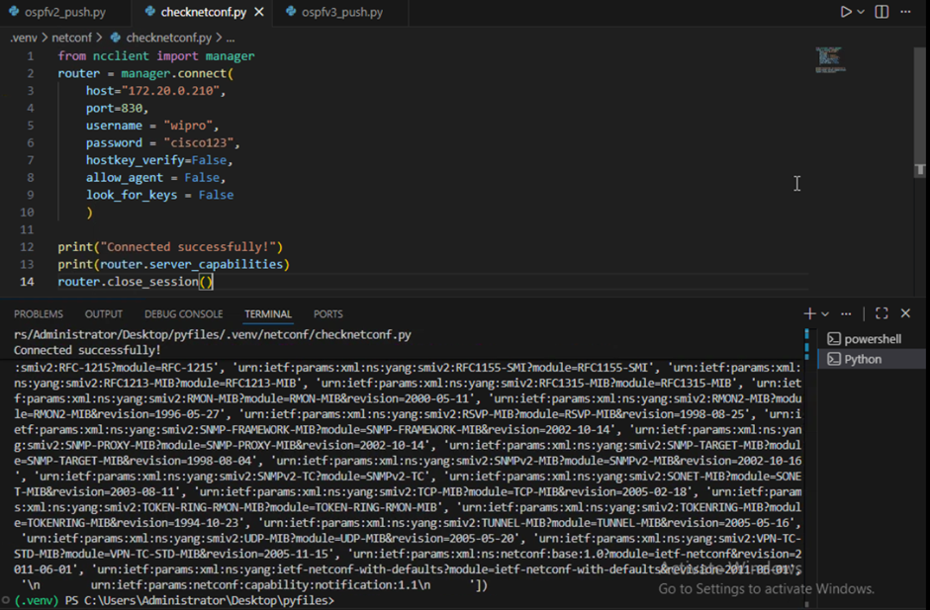
Python Script — Push OSPF Using NETCONF
- Connect to router using ncclient manager
- Verify server capabilities
- Use edit-config operation to apply OSPFv2 configuration to the running datastore
- Close session after testing

from ncclient import manager

ROUTER_IP = "172.20.0.210"
USERNAME = "wipro"
PASSWORD = "cisco123"

ospfv2_config = """
<config>
<native xmlns="http://cisco.com/ns/yang/Cisco-IOS-XE-native">

<router>
<ospf xmlns="http://cisco.com/ns/yang/Cisco-IOS-XE-ospf">

<id>1</id>

<router-id>1.1.1.1</router-id>

<network>
<ip>192.168.1.0</ip>
<mask>0.0.0.255</mask>
<area>0</area>
</network>

<network>
<ip>192.168.2.0</ip>
<mask>0.0.0.255</mask>
<area>0</area>
</network>

</ospf>
</router>

</native>
</config>
"""

with manager.connect(
host=ROUTER_IP,
port=830,
username=USERNAME,
password=PASSWORD,
hostkey_verify=False
) as m:

print("✅ Connected to Router3 NETCONF")

response = m.edit_config(target="running", config=ospfv2_config)

print("✅ OSPFv2 Configuration Pushed Successfully!")
print(response)

output :

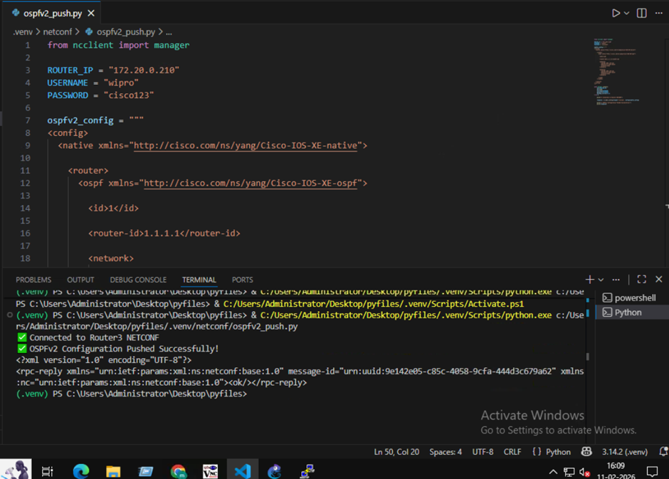

Python Script 2 — Push OSPFv3 (IPv6) via NETCONF (Router3)

Connects to Router using NETCONF
Sends XML configuration
Enables IPv6 routing
Creates OSPFv3 process 10
Prints confirmation

from ncclient import manager
ROUTER_IP = "172.20.0.210"
USERNAME = "wipro"
PASSWORD = "cisco123"

ospfv3_config = """
<config>
<native xmlns="http://cisco.com/ns/yang/Cisco-IOS-XE-native">

<ipv6>
<unicast-routing/>

<router>
<ospf>
<id>10</id>
</ospf>
</router>

</ipv6>

</native>
</config>
"""

with manager.connect(
host=ROUTER_IP,
port=830,
username=USERNAME,
password=PASSWORD,
hostkey_verify=False
) as m:

print("✅ Connected to Router3 NETCONF")

response = m.edit_config(target="running", config=ospfv3_config)

print("✅ OSPFv3 Process Created Successfully!")
print(response)

OUTPUT:
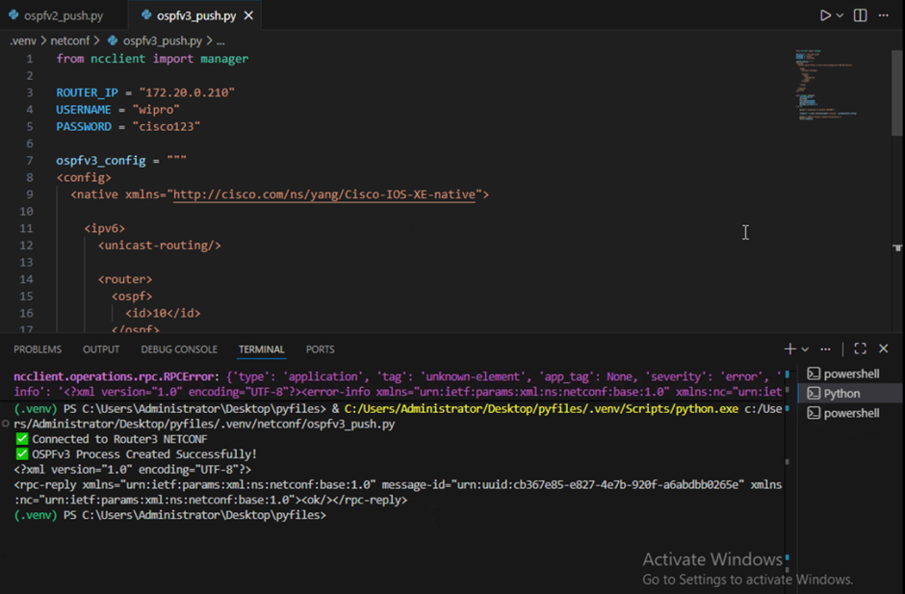

Manual Configuration vs Automated Configuration

Aspect | Manual Configuration (CLI Based) | Automated Configuration (NETCONF + Python)
Configuration Method | Router CLI commands entered manually | Python script using NETCONF (ncclient)
Protocols Configured | OSPFv2, OSPFv3, EIGRP, GRE configured one-by-one on each router | OSPFv2 and OSPFv3 pushed automatically via XML
Time Required | High – configure each router separately | Low – script pushes config instantly
Human Errors | High chance (wrong area, wrong mask, typo errors) | Minimal errors (standardized XML template)
Scalability | Difficult for large networks | Easily scalable to many routers

